|  |  |
| --- | --- |
| **Topic** | Apache Kafka |
| **Document Name** | KAFKA-EX-02 |
|  |  |

|  |  |  |  |
| --- | --- | --- | --- |
| **Document Difficulty Level** | | | |
| **Beginner** | **Junior** | **Senior** | **Expert** |
| □ | ■ | □ | □ |

# Document History

|  |  |  |  |
| --- | --- | --- | --- |
| Date | Author | Ver | Comments |
| 05.03.2025 | Mennan Tekbir | 1.0 | Initial Draft |
| 05.03.2025 | Mehmet Erdem Önal | 1.1 | Revisions |

# Apache Kafka

## Exercise KAFKA-EX-02:

**Definiton:** Pull & run Kafka container from Docker Hub in your GCP or AWS cloud machine. (You can use confluent oﬀcial docker- [repo](https://github.com/confluentinc/cp-all-in-one/tree/7.5.0-post/cp-all-in-one) ). For being more practical, you can run in your local machine first, and then, you can switch to cloud machine.

**Note:** If you did not get a cloud machine previously, you may simply run it on your local machine.

**Hint:** [Run Apache Kafka using Docker](https://www.youtube.com/watch?v=8ZTTcAWMIAE)

Please provide screenshots to show your work.

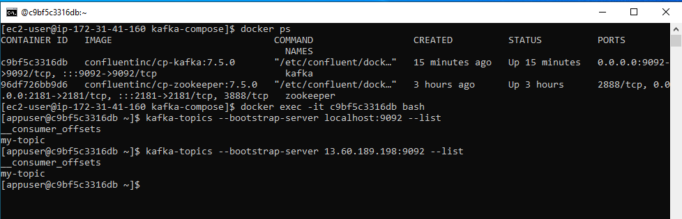

## KAFKA-EX-02 Solution:

**Your Answer:**